**Start-up Competition Toolkit**



**Disclaimer**

This project has received funding from the European Union’s Horizon 2020 research   
and innovation programme under Grant Agreement No. 864242

Topic: LC-SC3-SCC-1-2018-2019-2020: Smart Cities and Communities

The sole responsibility for the content of this publication lies with the authors.   
It does not necessarily reflect the opinion of the European Communities.   
The European Commission is not responsible for any use that may be made of the information contained thereiн.

**About SPARCS**

Sustainable energy Positive & zero cARbon CommunitieS demonstrates and validates technically and socioeconomically viable and replicable, innovative solutions for rolling out smart, integrated positive energy systems for the transition to a citizen centred zero carbon & resource efficient economy. SPARCS facilitates the participation of buildings to the energy market enabling new services and a virtual power plant concept, creating VirtualPositiveEnergy communities as energy democratic playground (positive energy districts can exchange energy with energy entities located outside the district). Seven cities will demonstrate 100+ actions turning buildings, blocks, and districts into energy prosumers. Impacts span economic growth, improved quality of life, and environmental benefits towards the EC policy framework for climate and energy, the SET plan and UN Sustainable Development goals. SPARCS co-creation brings together citizens, companies, research organizations, city planning and decision making entities, transforming cities to carbon-free inclusive communities. Lighthouse cities Espoo (FI) and Leipzig (DE) implement large demonstrations. Fellow cities Reykjavik (IS), Maia (PT), Lviv (UA), Kifissia (EL) and Kladno (CZ) prepare replication with hands-on feasibility studies. SPARCS identifies bankable actions to accelerate market uptake, pioneers innovative, exploitable governance and business models boosting the transformation processes, joint procurement procedures and citizen engaging mechanisms in an overarching city planning instrument toward the bold City Vision 2050. SPARCS engages 30 partners from 8 EU Member States (FI, DE, PT, CY, EL, BE, CZ, IT) and 2 non-EU countries (UA, IS), representing key stakeholders within the value chain of urban challenges and smart, sustainable cities bringing together three distinct but also overlapping knowledge areas: (i) City Energy Systems, (ii) ICT and Interoperability, (iii) Business Innovation and Market Knowledge.

**Partners**

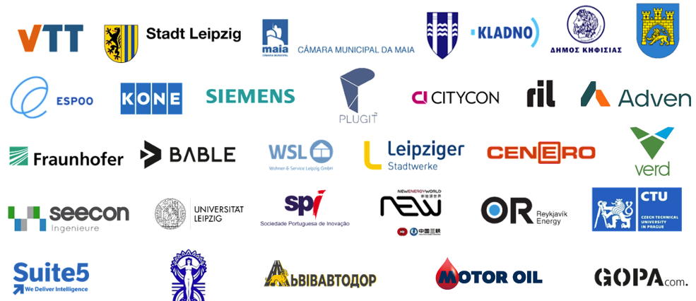

# Contents

Introduction 4

Part 1: The Fundamentals 5

1.1: Purpose 5

1.2: Approval 5

1.3: Funding 6

1.4: SWOT Analysis 7

Part 2: The People 10

2.1: Team 10

2.2: Partners 11

2.3: Jury 11

Part 3: The Competition 13

3.1: Stages 13

3.2: Prizes 13

3.3: Applicant Requirements 15

3.4: Criteria 15

3.5: Event(s) 16

Part 4: Communication 17

4.1: Media 17

4.2: Publications and Media Outlets 18

4.3: The Pitch 19

4.4: Potential Participants 21

4.5: Language Barriers 21

Part 5: Timeline 22

5.1: Key Dates 22

5.2: GANTT Chart 22

# Introduction

This toolkit is a simple step-by-step guide that organisers of startup competitions can use to help ensure they effectively manage competitions from start to finish and find proposals that fulfil their goals.

The sections in this toolkit are meant to be completed in the order they appear. In other words, you must first state the purpose of your competition and end by producing a comprehensive timeline. Doing so will ensure you stay on track at all times and not have to fill in any gaps as you organise your competition.

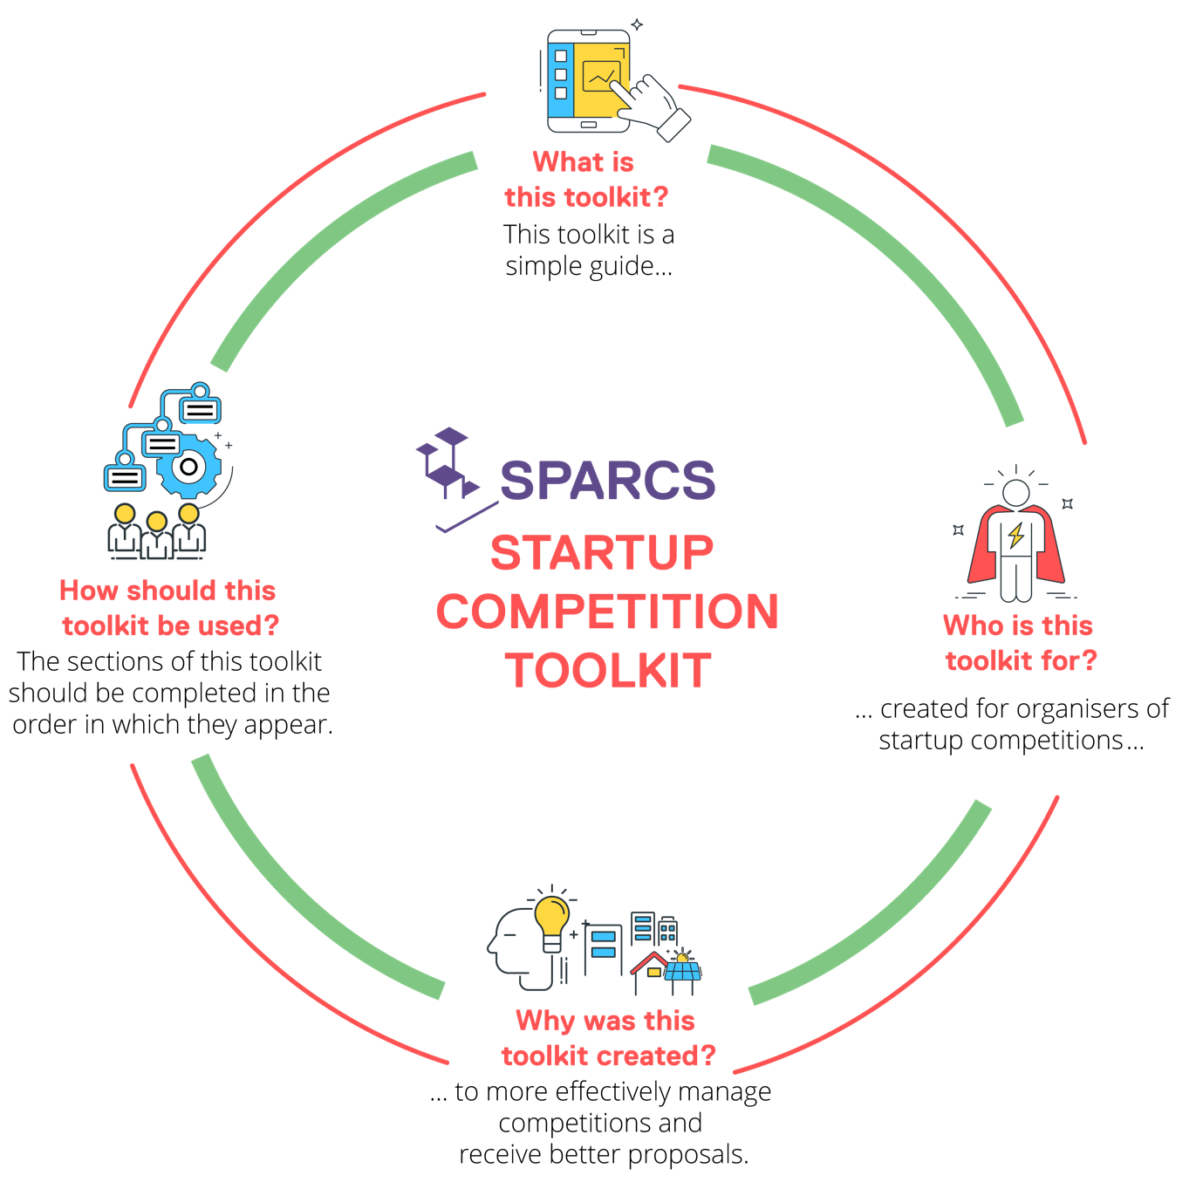

# Part 1: The Fundamentals

## 1.1: Purpose

A competition (or anything, for that matter) without a clear purpose is destined to fail. In no more than one sentence, describe the core reason behind the competition:

(Tip: keep asking yourself ‘why’ questions until you reveal the root cause — also taking into account that, these days, people highly value companies that can make a meaningful impact on society and/or the environment.)

|  |
| --- |
|  |

## 1.2: Approval

Do you have full approval to host this competition?

____ Yes ____ No

If not, identify whom you need to obtain approval from. Only include those with the authority to reject your proposal.

(Add/remove rows to/from the table as necessary)

|  |  |  |  |
| --- | --- | --- | --- |
| Name | Title | Organisation | Contact Information |
|  |  |  |  |
|  |  |  |  |
|  |  |  |  |
|  |  |  |  |
|  |  |  |  |
|  |  |  |  |
|  |  |  |  |
|  |  |  |  |

## 1.3: Funding

How much will organising this competition cost, approximately?

|  |
| --- |
|  |

Will you be able to cover the entire cost yourself?

____ Yes ____ No

If not, from where do you plan to source funds?

(Add/remove rows to/from the table as necessary)

|  |  |  |  |
| --- | --- | --- | --- |
| Source | Amount (in EUR) | Person to Contact | Contact Information |
|  |  |  |  |
|  |  |  |  |
|  |  |  |  |
|  |  |  |  |
|  |  |  |  |
|  |  |  |  |
|  |  |  |  |
|  |  |  |  |
|  |  |  |  |
|  |  |  |  |

How do you plan to allocate the funds? For example, how much do you envision setting aside for social media promotion?

(Add/remove rows to/from the table as necessary)

|  |  |  |
| --- | --- | --- |
| Purpose | Earmarked Amount (in EUR) | Percentage of Total Necessary Funds |
|  |  |  |
|  |  |  |
|  |  |  |
|  |  |  |
|  |  |  |
|  |  |  |
|  |  |  |
|  |  |  |
|  |  |  |
|  |  |  |

## 1.4: SWOT Analysis

‘SWOT’ stands for strengths, weakenesses, opportunities, and threats. A SWOT analysis is a simple tool used by businesses to assess notable internal and external factors that are affecting, and that can affect, the success of a venture (e.g. a campaign or the launch of a new brand). The idea is to leverage strengths to compensate for weaknesses; seize opportunities; and prevent and mitigate any possible threats.

In the context of this competition:

* What are your organisation’s strengths and weaknesses?
* What opportunities can you take advantage of?
* What could threaten the success of your competition?

Plot these strengths, weaknesses, opportunities, and threats in the chart below:

|  |  |
| --- | --- |
| STRENGTHS | WEAKNESSES |
|  |  |
| OPPORTUNITIES | **THREATS** |

How will you leverage your strengths?

|  |
| --- |
|  |

How will you address your weaknesses?

|  |
| --- |
|  |

How will you seize these opportunities?

|  |
| --- |
|  |

How will you reduce the risk of these threats occurring? And, if they occur, how will you deal with them?

(Tip: play Devil’s advocate and think of everything that could possibly go wrong.)

|  |
| --- |
|  |

# Part 2: The People

## 2.1: Team

Who will be involved in organising the competition, and what specific roles will they play?

(Add/remove rows to/from the table as necessary)

|  |  |  |  |  |  |
| --- | --- | --- | --- | --- | --- |
| Name | Organisation | Title | Agreed to Participate Yet?  (Yes or No) | Role in Competition | Contact Information |
|  |  |  |  |  |  |
|  |  |  |  |  |  |
|  |  |  |  |  |  |
|  |  |  |  |  |  |
|  |  |  |  |  |  |
|  |  |  |  |  |  |
|  |  |  |  |  |  |
|  |  |  |  |  |  |
|  |  |  |  |  |  |
|  |  |  |  |  |  |

## 2.2: Partners

What organisations will you partner with in organising this competition? What specific roles will they play?

(Tip: start by listing the partners upon whom the success of your competition depends the most.)

(Add/remove rows to/from the table as necessary)

|  |  |  |  |  |
| --- | --- | --- | --- | --- |
| Organisation | Agreed to Participate Yet? (Yes or No) | Role in Competition | Contact Person | Contact Information |
|  |  |  |  |  |
|  |  |  |  |  |
|  |  |  |  |  |
|  |  |  |  |  |
|  |  |  |  |  |
|  |  |  |  |  |
|  |  |  |  |  |
|  |  |  |  |  |
|  |  |  |  |  |
|  |  |  |  |  |

## 2.3: Jury

Who will serve as jury members? What are their credentials?

(Add/remove rows to/from the table as necessary)

|  |  |  |  |  |
| --- | --- | --- | --- | --- |
| Name | Organisation | Credentials | Agreed to Participate Yet?  (Yes or No) | Contact Information |
|  |  |  |  |  |
|  |  |  |  |  |
|  |  |  |  |  |
|  |  |  |  |  |
|  |  |  |  |  |
|  |  |  |  |  |
|  |  |  |  |  |
|  |  |  |  |  |
|  |  |  |  |  |
|  |  |  |  |  |

# Part 3: The Competition

## 3.1: Stages

How many stages will there be in this competition, and what will happen in each stage?

(Add/remove rows to/from the table as necessary)

|  |  |  |
| --- | --- | --- |
| Stage # | Description | Duration |
|  |  |  |
|  |  |  |
|  |  |  |
|  |  |  |
|  |  |  |
|  |  |  |
|  |  |  |
|  |  |  |
|  |  |  |
|  |  |  |

## 3.2: Prizes

How many prizes will be awarded? What are these prizes?

(Add/remove rows to/from the table as necessary)

|  |  |
| --- | --- |
| Prize Place (e.g. 1st, 2nd, 3rd, etc.) | Description |
|  |  |
|  |  |
|  |  |
|  |  |
|  |  |
|  |  |
|  |  |
|  |  |
|  |  |
|  |  |

What will happen in the event of a tie?

|  |
| --- |
|  |

## 3.3: Applicant Requirements

What are the minimum requirements applicants must meet in order to be eligible to participate? Consider such things as:

* Location/country of incorporation
* Citizenship
* Language proficiency
* Political affiliations

## 3.4: Criteria

What criteria will you use to evaluate proposals? What weight will you assign to each criterion (i.e. how relatively important is each one)? What stage does each criterion apply to?

The following are examples of criteria organisers have used in past competitions:

* Degree of innovation
* Realisation potential
* Understanding of challenge
* Team quality
* Presentation quality
* Scalability
* Sustainability (social, environmental, and economic)
* Customer value
* Inclusiveness

(Add/remove rows to/from the table as necessary)

|  |  |  |  |
| --- | --- | --- | --- |
| Criterion | Description | Percentage Weight | Relevant Stage |
|  |  |  |  |
|  |  |  |  |
|  |  |  |  |
|  |  |  |  |
|  |  |  |  |
|  |  |  |  |
|  |  |  |  |
|  |  |  |  |
|  |  |  |  |
|  |  |  |  |

## 3.5: Event(s)

How many events will be held during the competition? Where and when will these take place? Who will attend them? Who will host them? What KPIs (key performance indicators) will you use to gauge their success?

(Add/remove rows to/from the table as necessary)

|  |  |  |  |  |  |  |
| --- | --- | --- | --- | --- | --- | --- |
| Event Description | Date | Type (In-Person, Online, or Hybrid?) | Venue (if Applicable) | Attendees | Host | Key Performance Indicators |
|  |  |  |  |  |  |  |
|  |  |  |  |  |  |  |
|  |  |  |  |  |  |  |
|  |  |  |  |  |  |  |
|  |  |  |  |  |  |  |
|  |  |  |  |  |  |  |
|  |  |  |  |  |  |  |
|  |  |  |  |  |  |  |
|  |  |  |  |  |  |  |
|  |  |  |  |  |  |  |

# Part 4: Communication

## 4.1: Media

What paid, earned, shared, and owned media will you use to promote the competition?

* **Paid media** are media you have to pay to publish. Examples of paid media include advertisements and advertorials you would pay for to promote the competition.
* **Earned media** are media that are generated as a result of your communication efforts (i.e. you do not pay for earned media). Examples of earned media include newspaper articles written about the competition.
* **Shared media** are media about you that are shared by others. Examples of shared media include retweets of your posts on Twitter and Facebook posts published by you that your followers (and others) share with their friends.
* **Owned media** are media you have the ability to publish at any time (i.e. their publication does not depend on anyone else). Examples of owned media include your blog articles, press releases, and newsletters about the competition.

Fill in the chart below:

(Tip: think about how to use paid and owned media to generate earned and shared media.)

|  |  |
| --- | --- |
| PAID | EARNED |
| SHARED | **OWNED** |

## 4.2: Publications and Media Outlets

What publications and media outlets might be interested in publishing articles and/or advertorials about the competition? Who should be contacted in each case?

(Add/remove rows to/from the table as necessary)

|  |  |  |  |  |  |
| --- | --- | --- | --- | --- | --- |
| Publication/Media Outlet Name | Subject | Language | Article or Advertorial? | Person to Contact | Contact Information |
|  |  |  |  |  |  |
|  |  |  |  |  |  |
|  |  |  |  |  |  |
|  |  |  |  |  |  |
|  |  |  |  |  |  |
|  |  |  |  |  |  |
|  |  |  |  |  |  |
|  |  |  |  |  |  |
|  |  |  |  |  |  |
|  |  |  |  |  |  |

## 4.3: The Pitch

To persuade journalists to write about the competition (whether before, during, or after it), you will need a compelling pitch. Your pitch should answer the question, ‘Why would anyone want to read a story about this competition?’ It may be obvious to you, but it won’t necessarily be to editors.

Your email pitch to editors should include:

* Your key messages (no more than three, and no longer than a sentence each; e.g. ‘This competition will help the city of X solve Y problem.’)
* Any ‘pegs’ that can add further relevance to the story (e.g. does the competition coincide with any significant events or anniversaries? Why is it especially important that this story be published *now*?)
* Information that showcases your credibility (e.g. have you or your organisation been featured in any prominent publications? Are there any quotes about you or your organisation from notable individuals you can use?)

What key messages do you want to communicate to editors?

(Tip: choose ones their readers would be interested in hearing.)

|  |
| --- |
|  |

|  |
| --- |
|  |

|  |
| --- |
|  |

What pegs can add further relevance to your pitch?

(Add/remove rows to/from the table as necessary)

|  |  |  |
| --- | --- | --- |
| Event/Occasion | Description | Date |
|  |  |  |
|  |  |  |
|  |  |  |
|  |  |  |
|  |  |  |
|  |  |  |
|  |  |  |
|  |  |  |
|  |  |  |
|  |  |  |

What information can you use to showcase your credibility?

|  |
| --- |
|  |

In 250 words or fewer, write an email pitch to an editor:

|  |
| --- |
|  |

## 4.4: Potential Participants

Are there any startup companies you think would make particularly good applicants? What are they, and how can they be contacted?

(Add/remove rows to/from the table as necessary)

|  |  |  |  |  |
| --- | --- | --- | --- | --- |
| Organisation | Description | Contact Person | Title | Contact Information |
|  |  |  |  |  |
|  |  |  |  |  |
|  |  |  |  |  |
|  |  |  |  |  |
|  |  |  |  |  |
|  |  |  |  |  |
|  |  |  |  |  |
|  |  |  |  |  |
|  |  |  |  |  |
|  |  |  |  |  |

## 4.5: Language Barriers

How will you deal with any potential language barriers (internally and externally)?

|  |
| --- |
|  |

# Part 5: Timeline

## 5.1: Key Dates

Preparation of the organisation will begin on:

|  |
| --- |
|  |

The competition will end on:

|  |
| --- |
|  |

All activity surrounding the competition (e.g. promotion) will end on:

|  |
| --- |
|  |

## 5.2: GANTT Chart

The creation of a detailed timeline with all activities listed is key to ensuring the success of any project. Using [Wrike](https://trial.wrike.com/web-based-gantt-chart-software-va/?targetID=kwd-22195350&gclsrc=aw.ds&ga_campaign=20032793251&ga_adgroup=151390748147&ga_keyword=gantt%20chart%20free&gad=1&gclid=EAIaIQobChMI3NX-kerq_gIVXvrjBx0QLA0jEAAYASAAEgJVfvD_BwE) (or a similar service), create a GANTT chart with every foreseen activity from the moment preparation for the competition begins to when all activity surrounding it ends.

To avoid any setbacks or crises, err on the side of caution and take into account all possible delays. For instance, consider that communication will be less frequent in summer months, and that you may therefore need to give jurors more time to confirm their availability. The more time you give yourself, the more room you will have to manoeuvre in the event of such delays.

Finally, while your GANTT chart should be as detailed as possible, the following are a few key deadlines that can help you get started:

* Final approval from those with decision-making authority
* Finalisation of board/committee
* Finalisation of jury
* Securing of each funding tranche
* Securing of venue(s)
* Commencement of promotional communication
* Finalisation of participant shortlist
* Beginnings and ends of each competition stage
* Public announcement of winner(s)
* End of post-competition communication